

User Manual for Raj attendnace Mobile application

Date: 06-11-2023

12/21/2023

Contents

1. Raj Attendance: 2

1.1. Splash Screen: 2

1.2. Login Screen: 3

1.3. Attendance Mark In and Mark Out Screen: 5

1. Raj Attendance: The Raj Attendance Mobile application was designed for Government organizations by the Government of Rajasthan to improve the Productivity of Government employees. The Biometric Attendance Management System authenticates attendance using the Aadhaar number created by UIDAI and Face Authentication.
   1. Splash Screen: This screen will be the first screen of this application which is a splash screen.

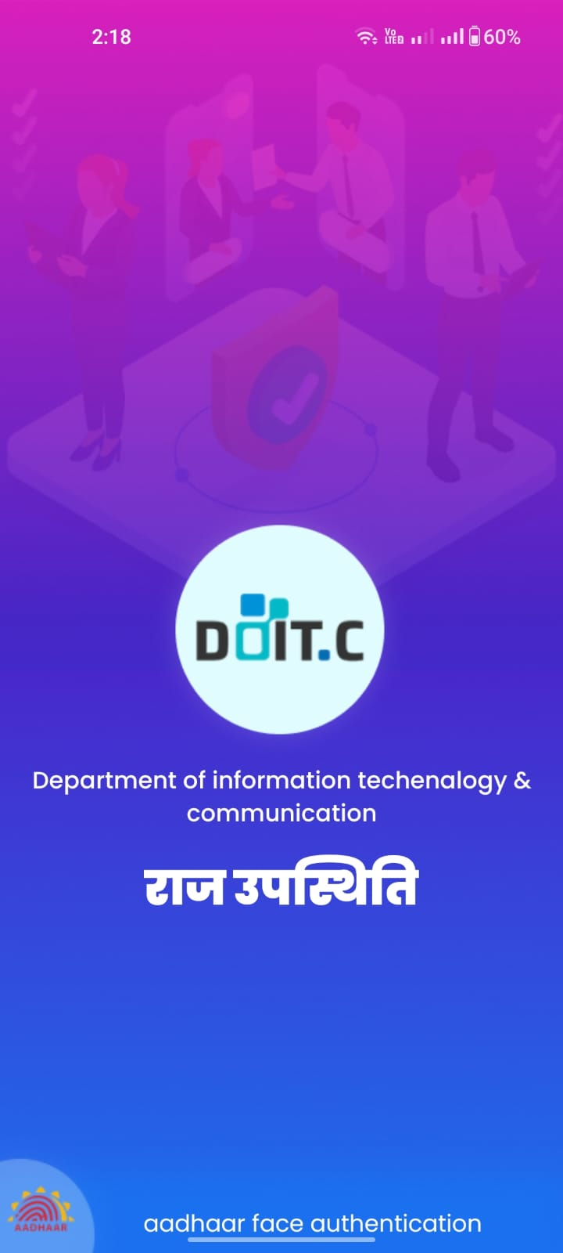

* 1. Login Screen: After the Splash screen, login screen will display, where user will login with the SSO Id and Password.

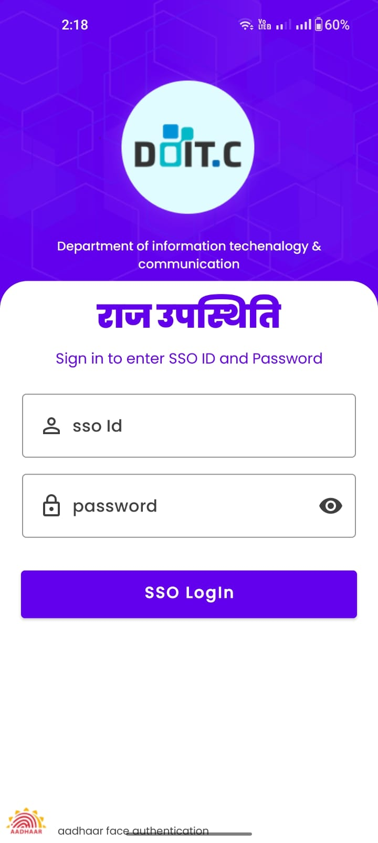

Click here to view the entered password

* Enter the **SSO ID**
* Enter the **Password**
* Click on the SSO Login button

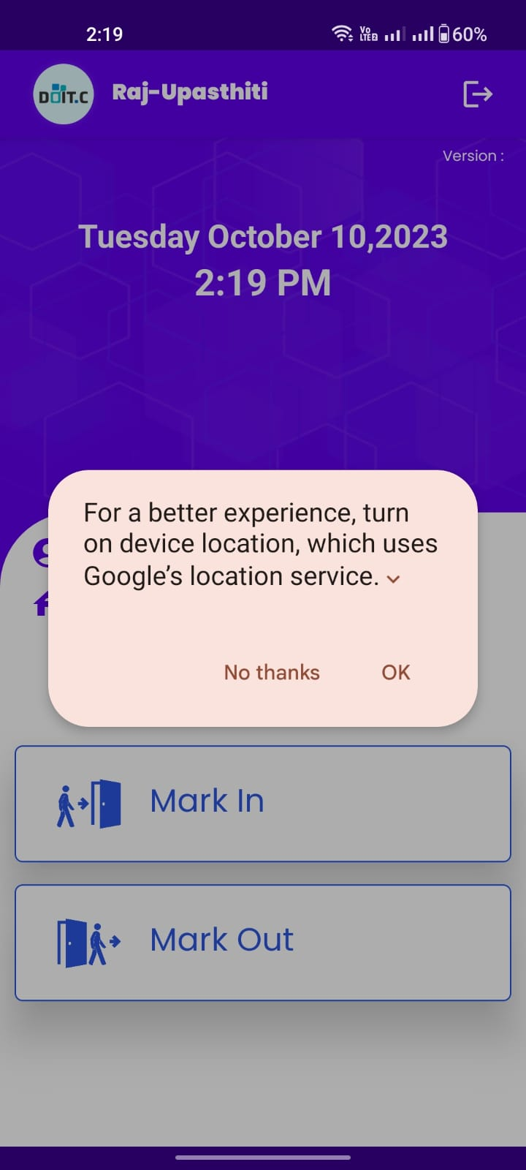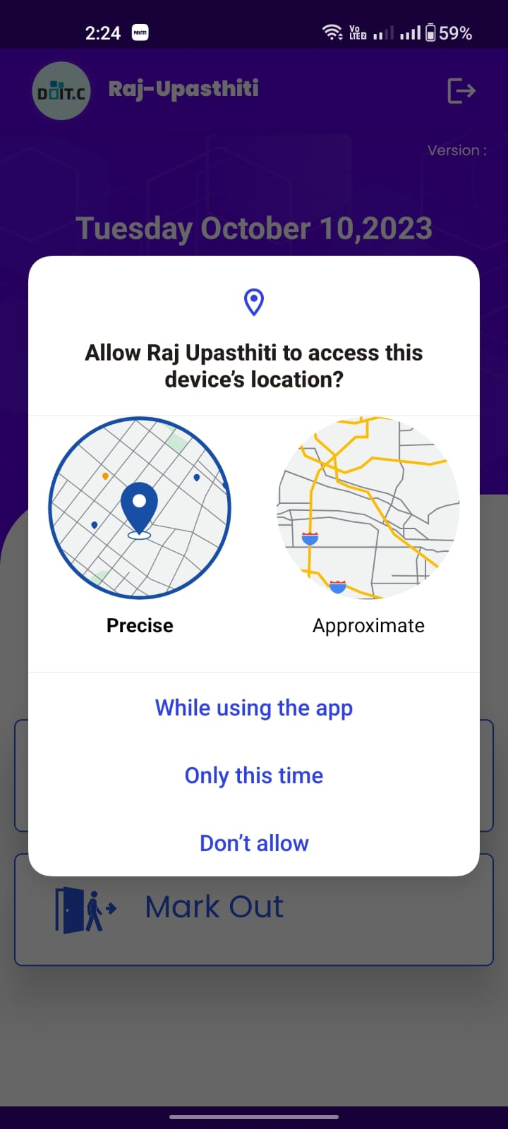

Select while using the App

* After login the application user must allow the **location**.
* In first screen user must select the **while using the app**.
* User must on the **GPS location**.
  1. Attendance Mark in and Mark Out Screen: After login, Attendance Mark in and Mark Out Screen will display, where the user can Mark in and Mark Out through face authentication.

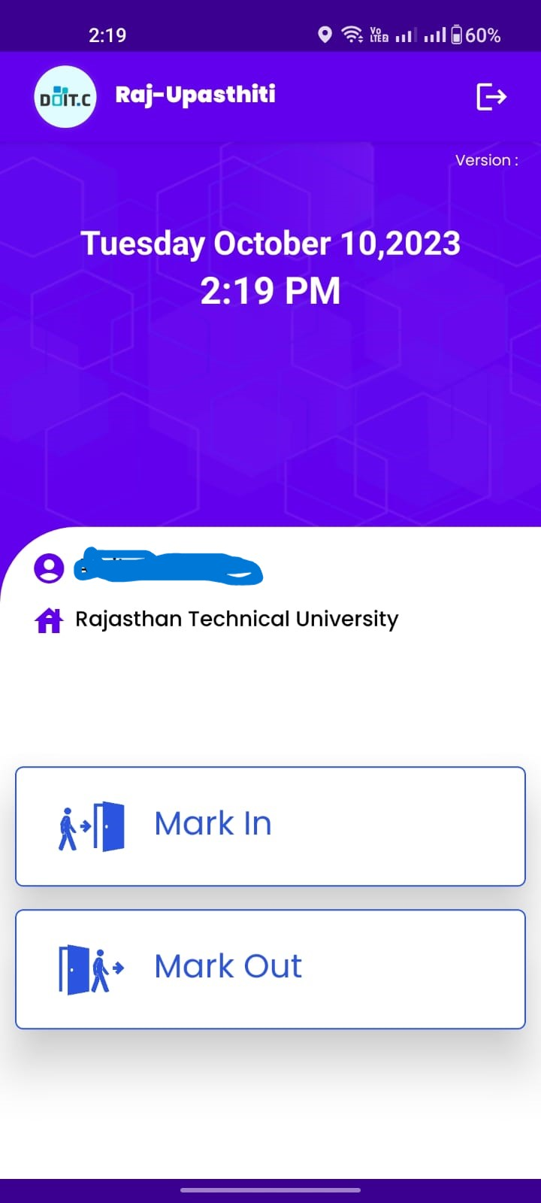

* Click on the **Mark In** button.

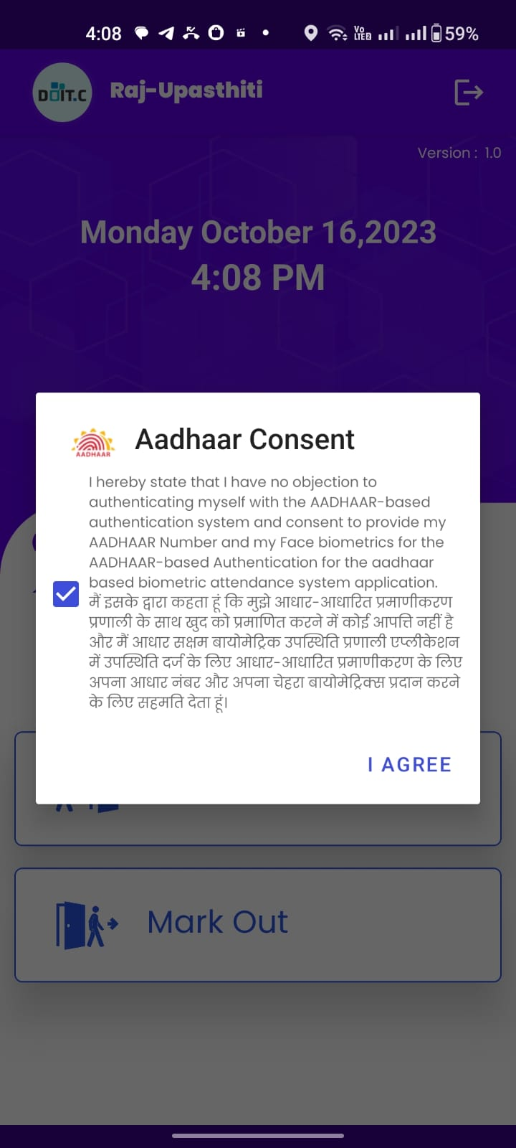

Click here to agree the Aadhaar consent

* After click on the Mark In button this screen will show.
* User must accept the **Aadhaar consent**.
* After accept the consent click on the **I Agree**.

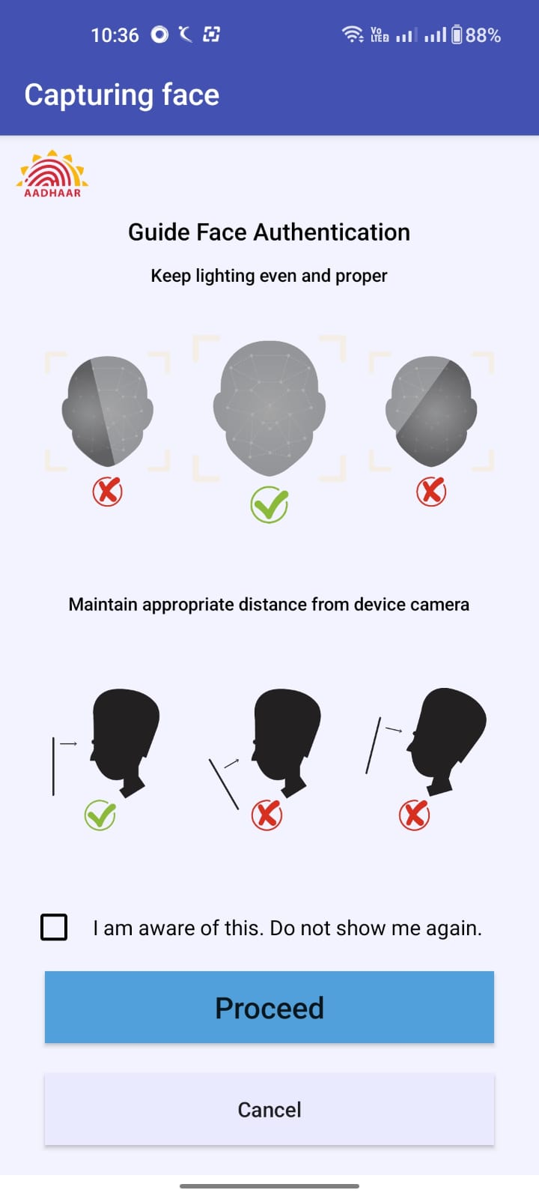

* This is guiding face authentication screen, where user must follow the instruction before marking the attendance.
* If the user selects the check box, this screen will not reappear.
* Click on the Proceed.

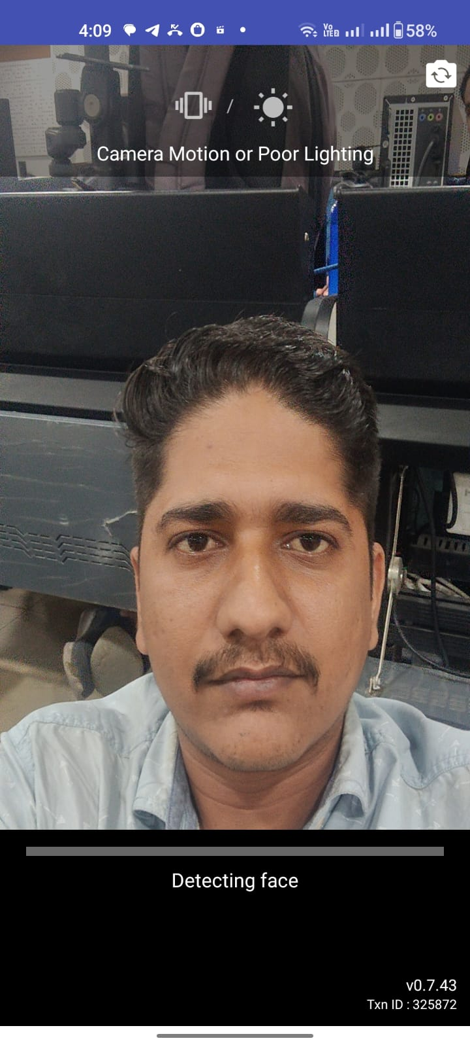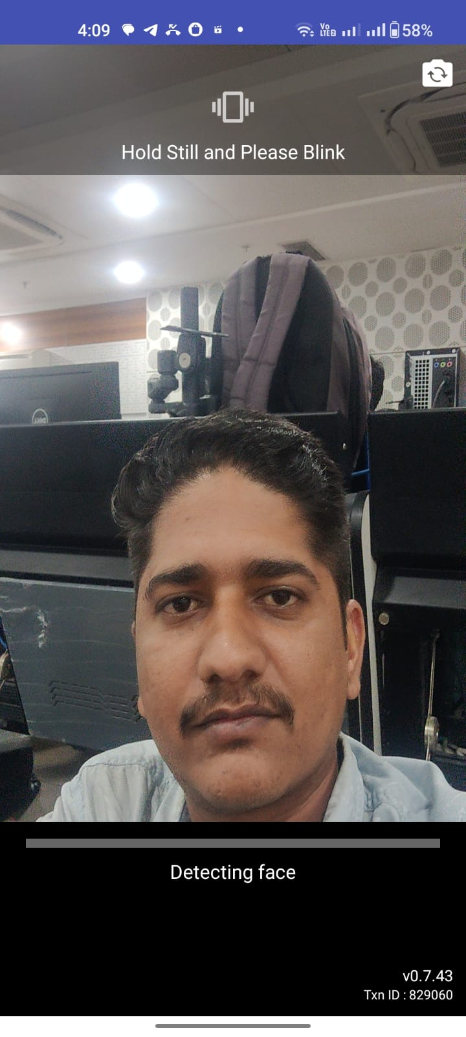

Poor lighting notification will show here

Eyes blink notification will show here

* After accept the consent, camera will open.
* User must blink their eyes
* There should not be **poor lighting** as seen in the second screen.

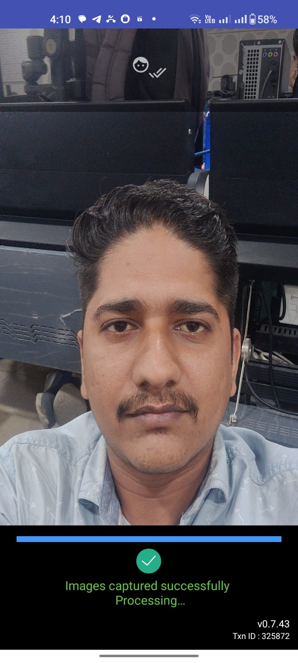

* After detect the face this screen will show.
* **Image captured successfully and processed**.

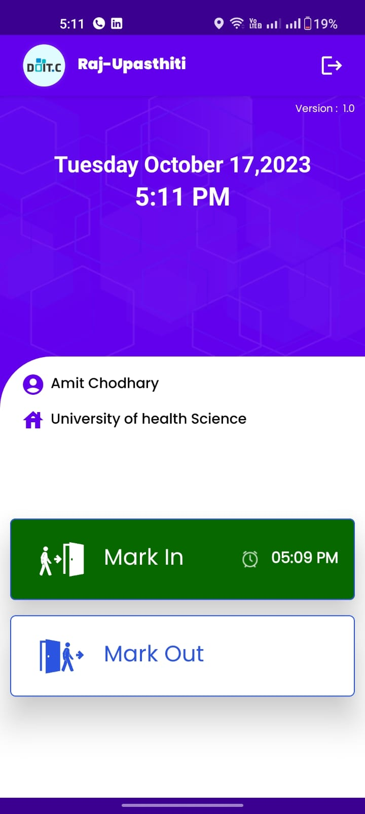

* After successfully capturing the image, Attendance will be marked successfully and the mark-in button will be green.

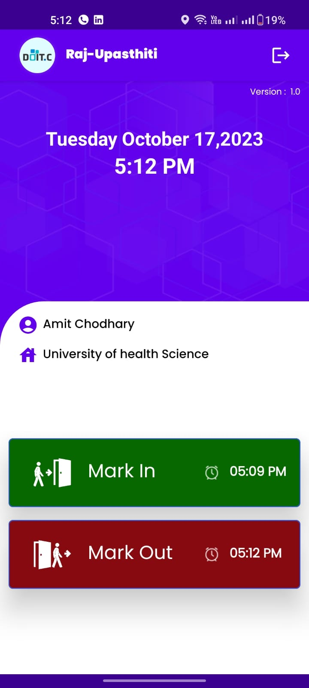

Click here to Mark Out

* The user will click on the Mark out button, and attendance will be marked out.
* After successfully marked out, the Mark out button will be red

**The End**